**Chapter 3: Normal Distribution**

**Guided Practice 3.17**

1. **What is the 95th percentile for SAT scores?**

Given that **μ = 1500** and **σ = 300. Now we draw the picture:**

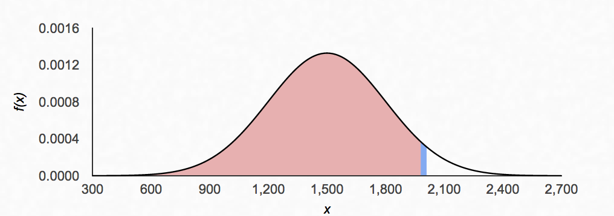

Now we want to find the Z-score at the 95th Percentile, which will be a positive value. Looking in the Z-table, We find Z falls in row 1.6 and column 0.05

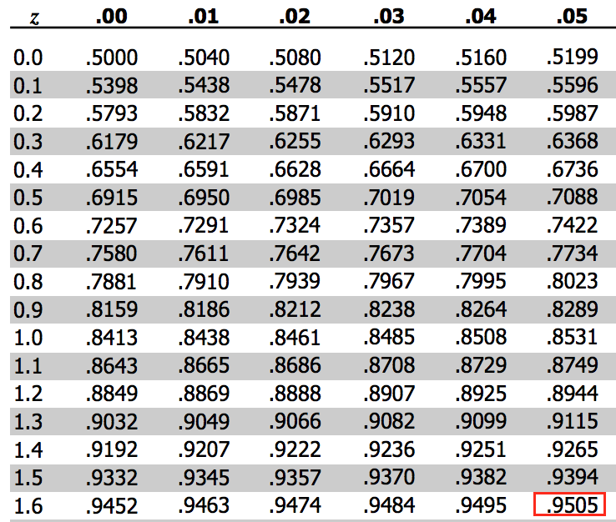

Hence Z95 is 1.65

Now we setup the Z-score formula:

1.65 = $\frac{X95-1500}{300}$

We solve the equation for X95

X95 = 1995

**This Yield 1995 as the score at the 95th Percentile.**

1. **What is the 97.5th percentile of male heights**

Given that **μ = 70** and **σ = 3.3. Now we draw the picture:**

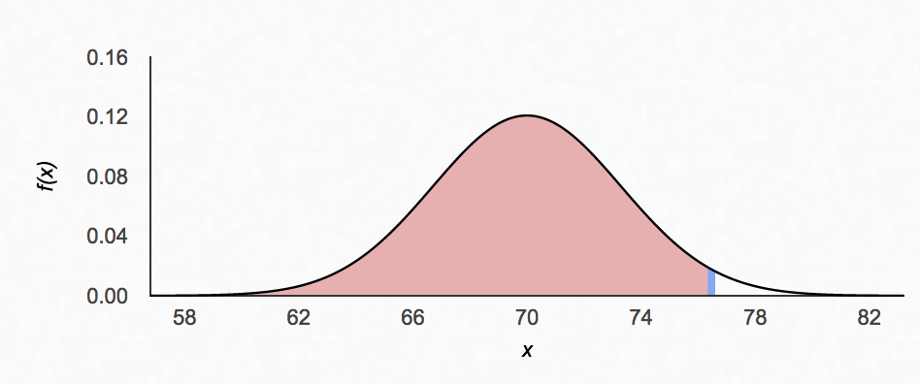

Now we want to find the Z-score at the 97.5 Percentile, which will be a positive value. Looking in the Z-table, We find Z falls in row 1.9 and column 0.06

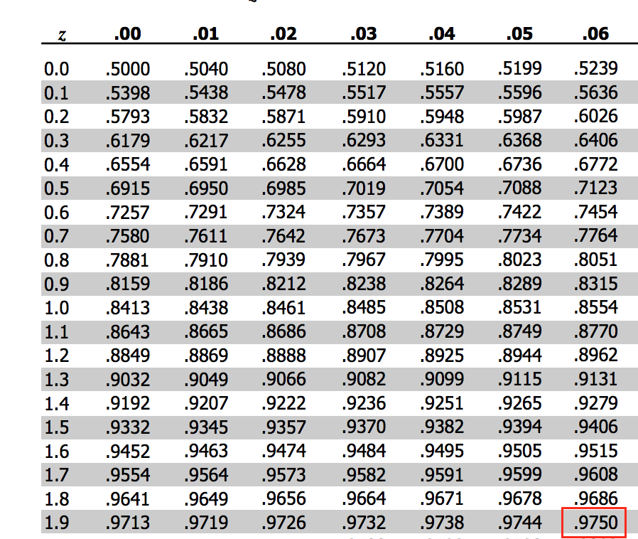

Hence, Z-score is : 1.96

Now we set up the Z-score forumula

1.96 = $\frac{X97.5-70}{3.3}$

We solve the equation for X97.5 = 76.5

**This yields 76.5 as the height at the 97.5th percentile**